Trouble Detail

Project | PIS-FRAME | Customer | IMCT
By | Chirayuth S. | Date | 21/02/2012
Problem | PIS Server not instruct and PIS Client cannot use CHANGE function
Cause | - From Application Eventlog as in following Image, database is busy trying to expand the database log file. Normally database log file will grow by 10% of current size, when the problem occurred, file size of log is around 35 GB, so when database is growing it has to grow more 3.5 GB, which take times and make it conflicted with the database usage from PIS program.  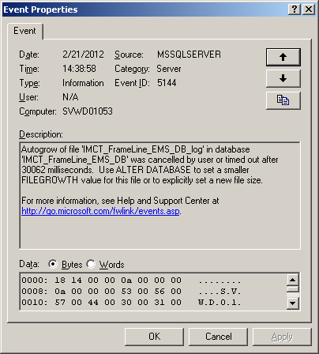  - Normally there is Windows scheduler that will automatically shrink the database log file so that the log file will not be too large, this windows scheduler is run as “Administrator” account. When the problem occurred, the windows scheduler hasn’t been run since 23/12/2011, because the windows is logon as “ISUZU\adminftfrm” account. so the scheduler cannot be started.
Relation
Solution | - Manually shrink database log (after shrunk log size reduced to around 8 MB)  - Changed the account of Windows scheduler from “Administrator” to “ISUZU\adminftfrm”.
Document
Remarks

